Hackathon 2

#1

select

substring('Home of the Hawks.',13,3);

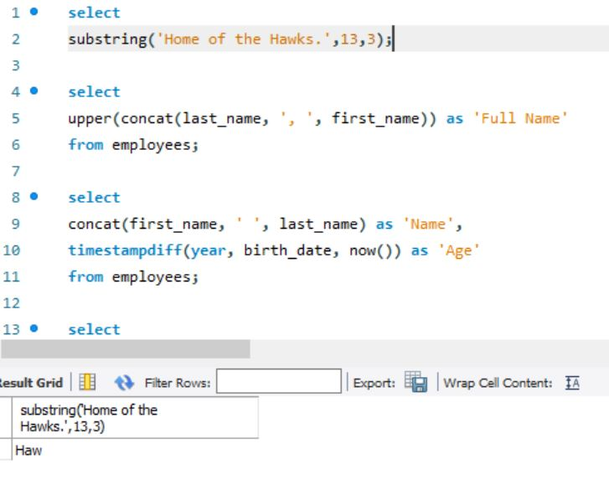

#2

select

upper(concat(last_name, ', ', first_name)) as 'Full Name'

from employees;

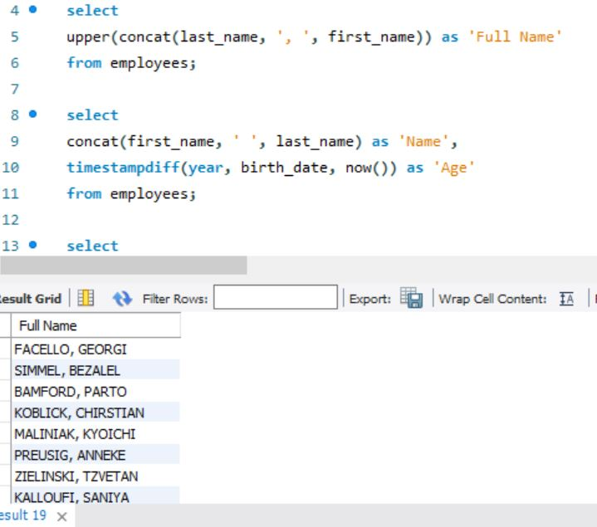

#3

select

concat(first_name, ' ', last_name) as 'Name',

timestampdiff(year, birth_date, now()) as 'Age'

from employees;

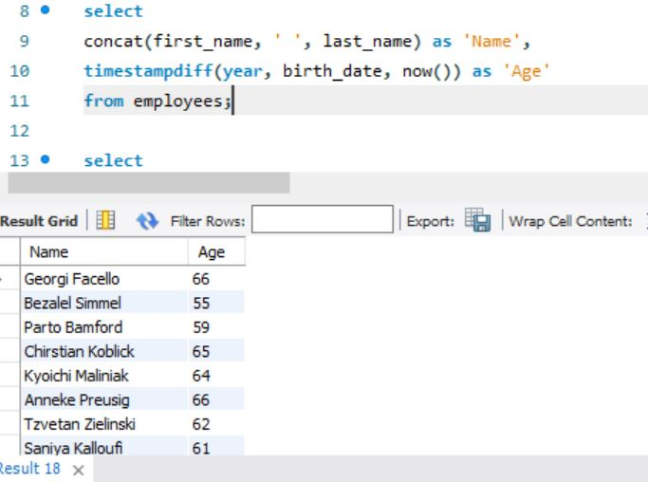

#4

select

timestampdiff(day, '2019-01-01', now()) as 'Days passed since January 1';

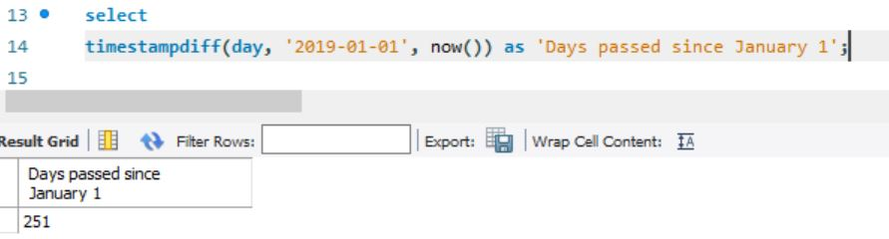

#5

select

emp_no,

format(salary/173.33, 0) as MonthlySalary

from salaries

order by MonthlySalary desc;

